)

)

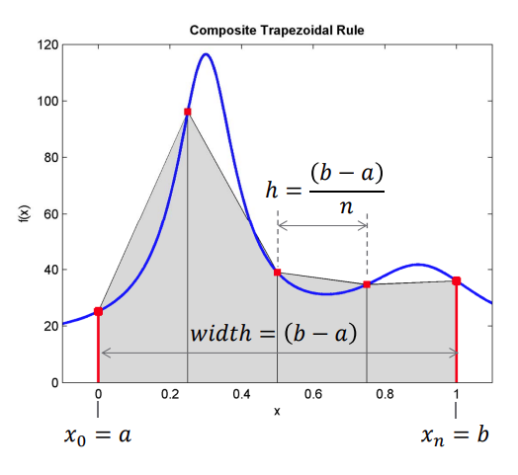

https://web.engr.oregonstate.edu/~webbky/MAE4020_5020_files/Section%208%20Integration.pdf